**COMP 3133 – Lab 6 – Node Test**

**Developer Note:**When working on your questions, please create seperate folder for your work.  This way you won’t putting all your code in the same file, which can pollute the global name space.  In short, it will prevent you from overwriting your own work and causing your code to compile incorrectly.

Organize your folder structure in this way.

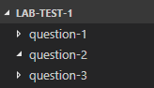

**Lab Test Reference**

You may use the Javascript ES6 and node.js online documentation  
<https://developer.mozilla.org/en-US/docs/Web/JavaScript>

<https://nodejs.org/en/docs/>

**Lab Test Submission**

Please submit your test at the end of the lab, using your student folder on the course GitHub repo

**Question 1: ES6 Features**

* Create a script with a function named ***lowerCaseWords*** that takes a mixed array as input.

The function will do the following.

* + return a promise that is resolved or rejected
  + filter the non-strings and lower case the remaining words
* Input



* Output



**Question 2: Promises**

* Given the script file ***callbacks.js***, write a script that does the following:
  + Create a method ***resolvedPromise*** that is similar ***to delayedSuccess*** and resolves a message after a timeout of 500ms.
  + Create a method ***rejectedPromise*** that is similar to ***delayedException*** and rejects an error message after a timeout of 500ms.
  + Call both promises separately and handle the resolved and reject results and then output to the console

***callbacks.js***

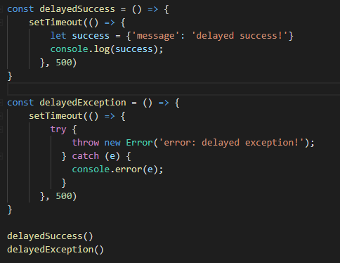

* Output  
  

**Question 3: File Module**

* Create a script that will do the following:

1. **Remove Log files**
   * remove all the files from the Logs directory, if exists
   * output the file names to delete
   * remove the Logs directory
2. **Create Log files**
   * create a Logs directory, if it does not exist
   * change the current process to the new Logs directory
   * create 10 log files and write some text into the file
   * output the files names to console
   * **Hint:** use the fs module and path module, and the process current working directory to build directory path. It is acceptable, to have a remove.js script and separate add.js script.

**> Output**

